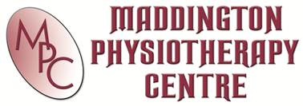
CLINICAL PILATES

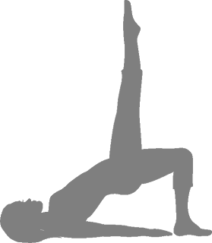

Interested in improving your flexibility and muscle strength? Let Maddington Physiotherapy Centre help you develop your “core” muscles allowing you to function at your best!
Our Head Pilates Instructor REBECCA has reached the top of her game with extensive professional training in Pilates instruction. Her passion for Pilates instruction will ensure that your body reaps the rewards of attending her classes.
Take advantage of the return of Rebecca and try a 6 weeks low impact high intensity Pilates workout program during January and February 2014!!
CLASS TIMES

1 – 2 PM Monday and Wednesday
6 – 7 PM Monday, Tuesday and Wednesday

PH: (08) 9459 5777 www.maddingtonphysio.com.au

